Rotary Accounts – Parent Fee

What is the Parent Fee Rotary Account Page 1
Budgeting the Parent Fee Account Page 2
Example T-Minus Timeline Page 3
Using a Parent Fee Account Page 4
Sample PO Requisition Page 5
Sample PO Reimbursement Page 6

Rotary accounts are held by the Board for use by a team, but using the money requires carefully following Board financial requirements. In a nutshell:

- You can only be reimbursed for expenses that are the subject of a pre-existing and approved purchase order
- You cannot submit a request for a purchase order unless you have sufficient funds in the account to pay for the purchase order

Careful planning is required to make sure you can use the funds when you want and for what you want

What is the Parent Fee Rotary Account?

The Parent Fee Rotary Account covers player-related team expenses during the season, primarily team meals or snacks. Because all players pay in, it is expected that all benefit (more or less) equally. The term Rotary is used to denote that it is held by the Board for the benefit of the team.

The fees collected are meant for use with the current season’s team, so amounts collected from this year’s team’s parents should generally be spent on the current year’s team. You can (and should) have a seed amount to cover off-season or pre-season purchases—and then leave a similar amount at the end of the season for next year’s team.

The email to parents about the fees should be reasonably clear as to the intended use of the funds—meals, snacks, t-shirt, senior gifts, etc.

This fund should NOT be used to purchase coaches’ gifts—the Parent Liaison (see below) should collect separately for that or should obtain a parent volunteer to collect voluntary contributions.

Budgeting the Parent Fee Account

At the end of a season or at least two months before a new season, the Coach will appoint a parent to act as Parent Liaison for the team to oversee the provision of team meals, snacks, etc. Typically, this parent is not a parent of a Senior. It can be split up by team (Varsity & JV), or the Parent Liaison can solicit other parents and can divide up games or events in any matter that makes sense.

The Coach and Parent Liaison should do the budgeting and planning early—once the season’s schedule is mostly developed, but probably a month or more before practices start.

The Coach and Parent Liaison should figure out season budget requirements. What games need meals? Snacks? Tournaments or other events? Develop a budget and set appropriate Parent Fee amounts to cover. Do this as early as possible! At least 45 days before the season starts.
Once the Parent Fee amount is determined, the Coach will contact the Athletic Department with the amount per player. The Athletic Department will work with HomeTown Ticketing to set up the online link so that parents can pay electronically.
The Parent Fee should include the processing and reporting fees that are involved in any electronic payment. For example, if the required parent fee is $60 per player to make budget, the fee set with Hometown should reflect those additional fees: so maybe $62.50 so that the account nets about $60. Refunds can only occur if the Coach and Athletic Director approve. The payment process through Hometown Ticketing should be live 35 days before practices start and should end halfway through the season unless otherwise approved by the Coach and Athletic Director. This timing of Parent Fees may be impacted if your sport cuts players (i.e., paid after cuts).
Because you cannot even get a purchase order submitted without sufficient money in the account, make sure everyone pays their parent team fee as quickly as practicable. The Parent Liaison should periodically confirm the remaining balance in the account by emailing a request to the BHS Athletic Department - Keri keri.altieri@bayschoolsohio.org.

Example T-Minus Timeline

End of Prior Season or 60 Days Before Practices Start – Coach designates a Parent Liaison for the team.

45 Days Before Practices Start – Coach and Parent Liaison determine team meal/snacks budget. Set Parent Fee amount and inform Athletic Department.

40 Days Before Practices Start – Parent Liaison obtains emails/contact information for player parents to secure volunteers for away meals and snacks, senior gifts, etc. and shares the processes with them.

35 Days Before Practices Start – Coach and Parent Liaison work with Athletic Department to get payment for team specific parent fees activated in Hometown Ticketing.

14 Days Before First Away Game – Depending on balance in account, Parent Liaison and any other parents should submit Parent Fee PO Requisition for entire season, or at least for earliest events to the extent the account balance will cover it.

Submit Parent Fee PO Requisition for rest of season as soon as Parent Fee Account balance will cover it.

First Practice – Parent Liaison validates parent fee payment status with the Athletic Department. Most parent fees should be paid at this time. Parent Liaison will update the Coach and send out reminders.

First Away Game – Parent Liaison or parent volunteer has obtained a meal or snack for the team. Submit Parent Fee Reimbursement form with relevant invoices.

If you are done with a PO but did not use everything, email Keri to have the remainder cancelled so that remaining funds can be released and made available for another PO Requisition.

Using a Parent Fee Account

All purchases must follow the District’s purchasing policy. And:

- You cannot be reimbursed for any purchase unless it was the subject of a pre-approved Purchase Order by the District.
- Assume it takes two (2) weeks to get a PO approved.
- Each parent who has volunteered for a meal will be submitting for reimbursement and must submit their own Parent Fee PO Requisition. Otherwise, one parent will have to take care of submitting receipts for others and then distributing reimbursement checks to the others.

To use your parent fees funds for the season, follow these steps:

- Have the Parent Liaison or if the Parent Liaison is engaging other parents, the parent responsible for the meal must complete the Parent Fee PO Requisition form available at https://www.bayrocketsassociation.com/forms.
- Email a copy of the form to the BHS Athletic Department - Keri Altieri (keri.altieri@bayschoolsohio.org).
- The BHS Athletic Department will enter the PO Requisition into the District’s financial system. It will go through an approval process with the District.
- Once approved, an email with the Purchase Order info will be sent to the email address listed on the Parent Fee PO Requisition form. Check the spam folder.
- If needed, get the Tax-Exempt Form from the BHS Athletic Department - Keri (keri.altieri@bayschoolsohio.org) to give to vendors. The District does not pay for or reimburse tax on purchases. Note that most food to-go is not taxed anyway, and different vendors have different policies and procedures for Tax-Exempt.
- Make your purchase after you have received the approved Purchase Order. If your receipt is dated before the PO was approved, you may not get reimbursed.
- Complete a Parent Fee Reimbursement form (available at https://www.bayrocketsassociation.com/forms) identifying the relevant Purchase Order and submit with detailed invoices/receipts to Keri Altieri as soon as possible for processing. This can be by scan/email to Keri or dropped off at the Main Office at the High School.
- A check will be mailed to the address on the PO.

An example of Parent Fee PO Requisition for boys’ soccer is below.
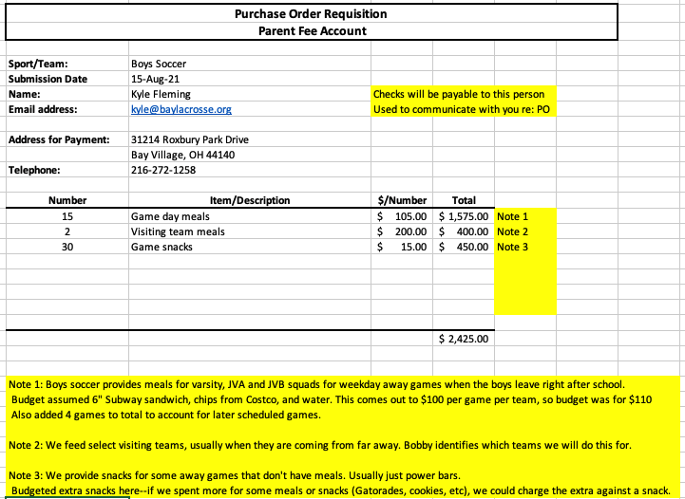

NB: Highlighted notes are for sample only and need not be included on your form.

The number of games for meals and snacks was based on the pre-season Varsity, JVA and JVB game schedule plus a couple extra games (not uncommon for soccer). The number of snacks was doubled—so we could use a “snack” purchase to cover any overages on the meals.

Remember: You don’t have to use it all, but you can’t go over. Depending on your budget and account balance:

- Add an extra couple games to PO request.
- Set the per/game budget on the high side.
- Add extra low cost items (for us, “Snacks”) to cover overages. Fifty “Snacks” of $20 offers more flexibility than twenty “Snacks” of $50.

If something comes up last minute and there is no time for a PO Requisition, based on prior approval by the Coach and the Athletic Department AD, the separate Bay Rockets Association Team Account may be used instead. The Coach and the Athletic Department AD will know if there are funds available in the BRA account.

An example of Parent Fee Reimbursement form.

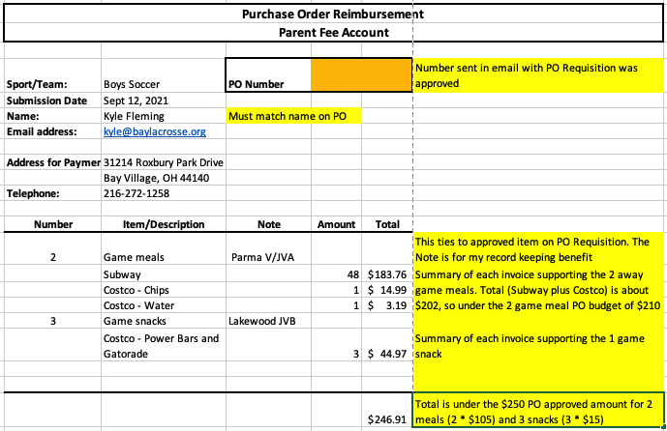

NB: Highlighted notes are for sample only and need not be included on your form.

If you go over the PO budget for one game, “make it up” on the next one and submit reimbursements together so that the two-game total is under the approved PO budget for two games. Or, if you budgeted extra small cost items in the PO (for us, “Snacks”), then use a “Snack” to cover the overage for a game.

